**RS-232 Loopback Rev.0**

**Testing**

# Test Setup

1. RS-232 Loopback Rev. 0 (DUT, device under test)
2. USB to RS-232 converter/cable
3. USB to Serial (TTL/3.3V) converter board with FTDI FT232
4. Ribbon cable (Box connector to Dupont)
5. Terminal Software YAT (<https://sourceforge.net/projects/y-a-terminal/>)

The DUT was either connected via the serial cable or the FTDI board to the computer. The proper COM-port was selected in YAT.

# Test Execution

## Test via the USB to RS-232

For the test, all jumpers except the RI jumper were placed. The selected (YAT) baud rate was 9600.

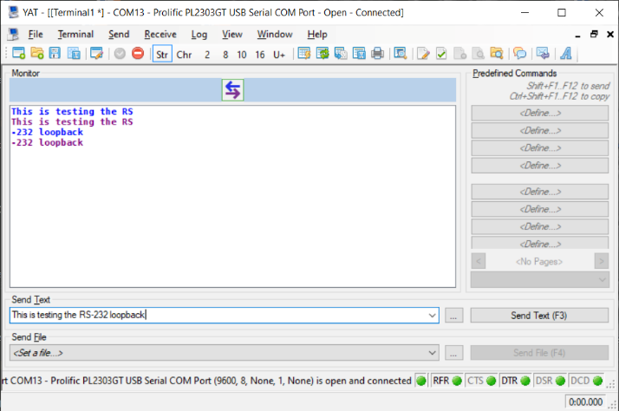

Figure 1: YAT - First test RTS (RFR) and DTS active

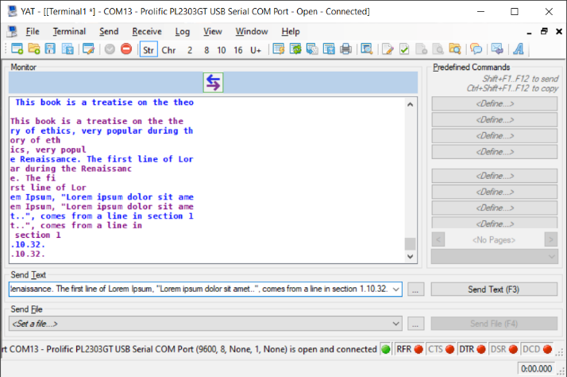

Figure 2: YAT - further testing RTS (RFR) and DTR inactive

While the data (text) is being transferred, the TxD LED LD2 is flickering. The sent text is being echoed by the loopback (as desired). The received (looped back) text is identical with the sent text. The line break is not, which is matter of the software.

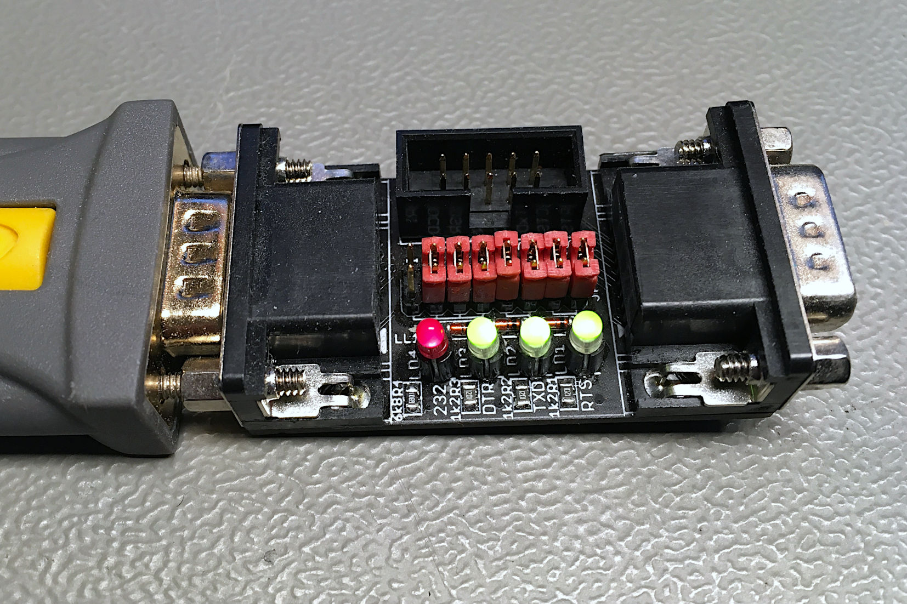

Figure 3: The RS-232 loopback connected to the RS-232 cable, RTS and DTR is inactive

The Level-Indicator LED lights (dim), while inactive and idling, all three bi-color LEDs (LD1-3) are green.

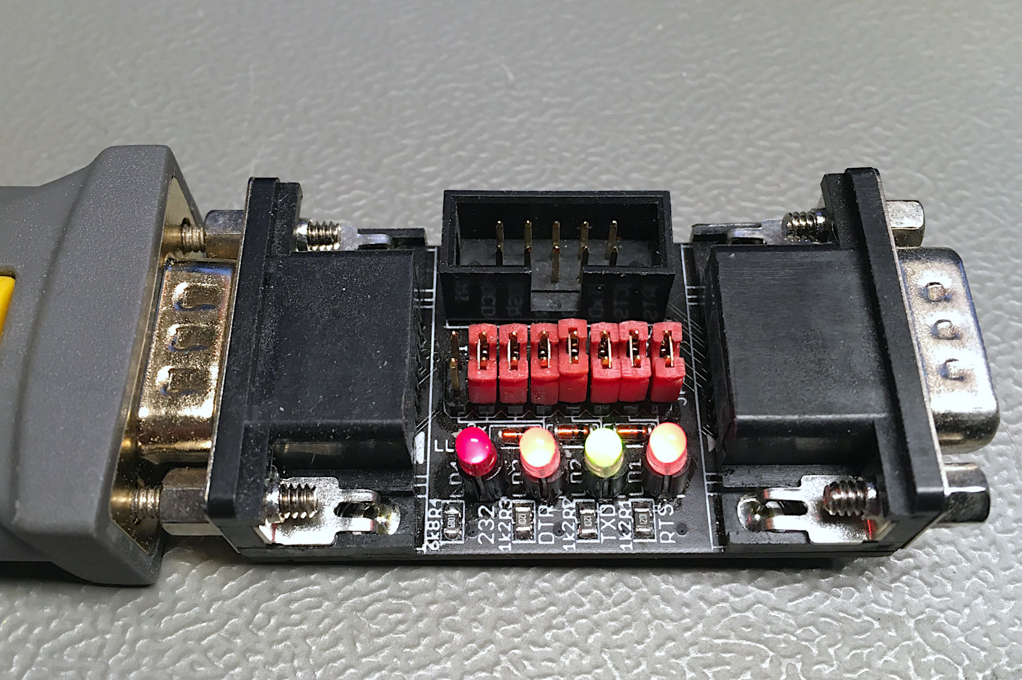

Figure 4: connected to RS-232, RTS and DTR active

When the status of RFR (RTS) is changed, the looped back status on CTS (indicated by YAT) changes accordingly. The same happens with DSR and DCD, if the DTR status is changed.

## Test via the USB to serial board (TTL)

The USB to serial board is connected to the box connector with the ribbon cable.

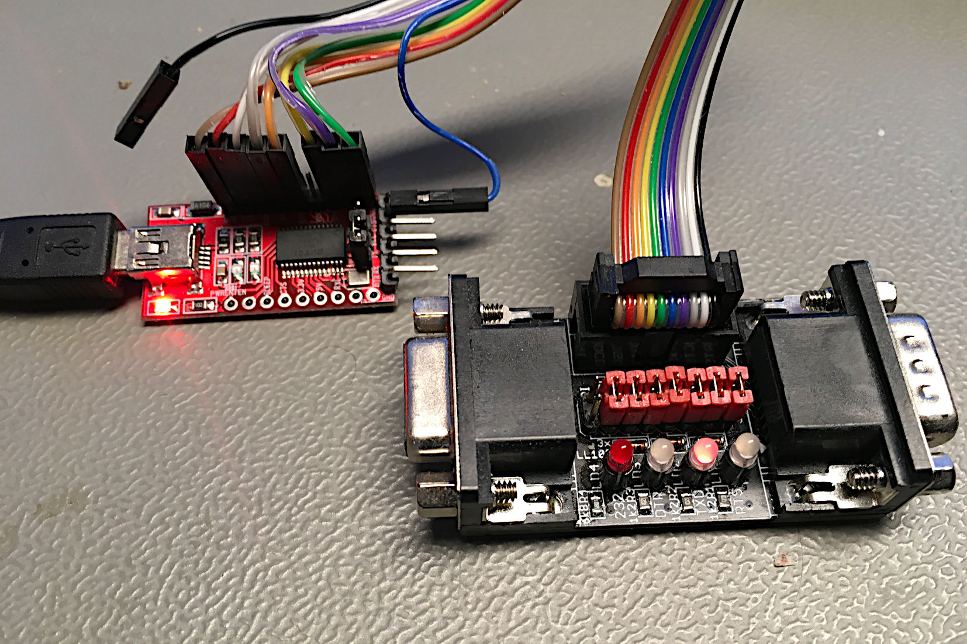

Figure 5: Test with the USB - (TTL) serial converter. Status: idle, RTS and DTR active

The level indicator LED LD4 (left, Figure 5) is off.

While data is being transferred, the TXD LED (LD2) is flickering. The RTS LED (LD1) is off while active and on while RTS is inactive. The DTR LED (LD3) indicated the DTR status correctly, too. The transmitted data is echoed back and the (this way) received text is identical with the transmitted text.

# Conclusion

The prototype is fully functional.